Ideation Phase
Brainstorm & Idea Prioritization Template
Date | 19-07-2026
Team ID
Project Name | SHOPEZ: E-Commerce Application
Marks | 4 marks

Brainstorm & Idea Prioritization Template
Brainstorming provides a collaborative environment where team members generate innovative ideas to solve a problem. The team discusses different solutions, evaluates their feasibility, and selects the best idea based on user needs, technical feasibility, and business value.
Step-1: Team Gathering, Collaboration and Select the Problem Statement
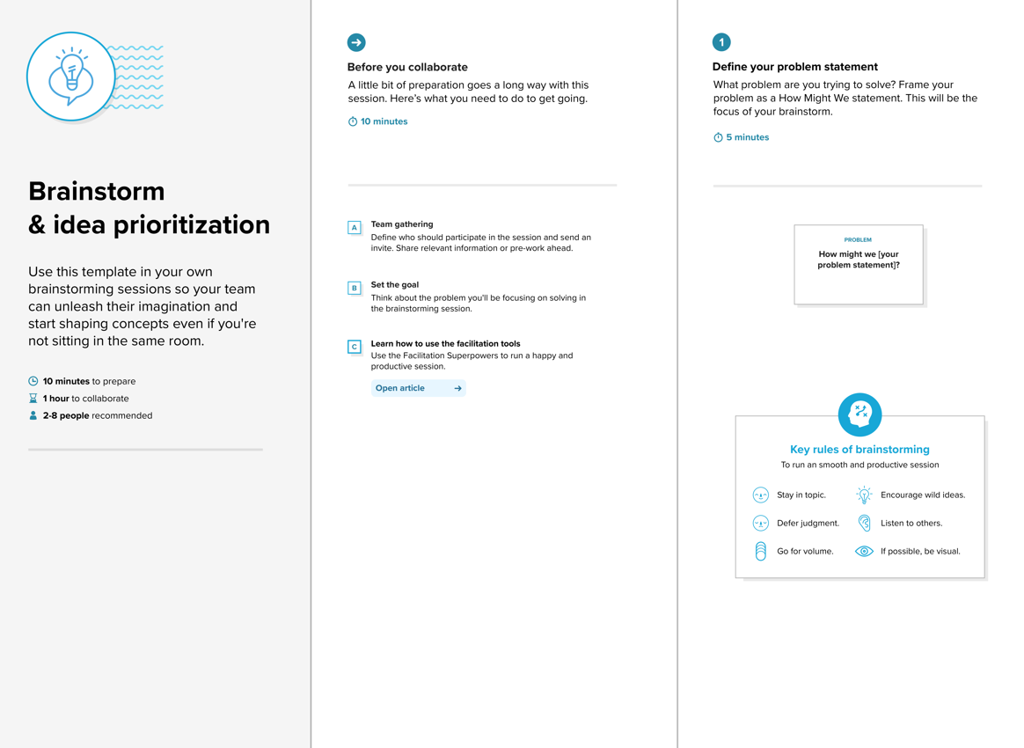

Step-2: Brainstorm, Idea Listing and Grouping
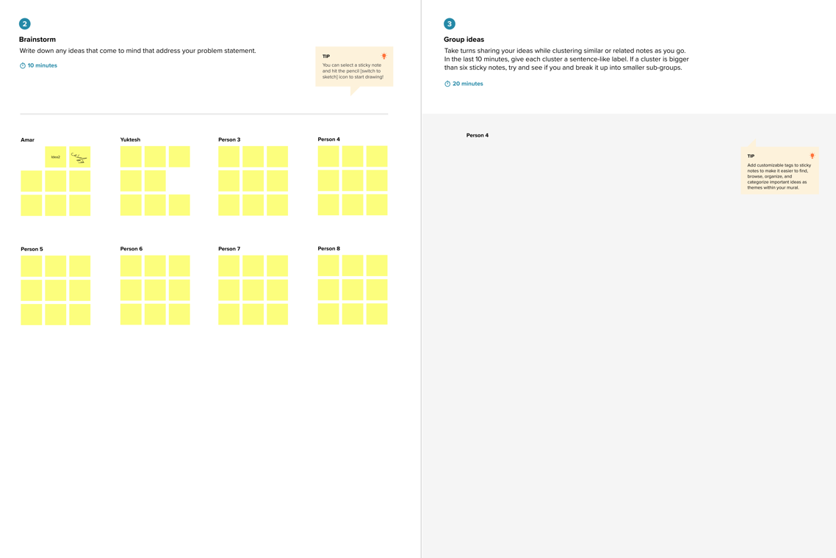

Step-3: Idea Prioritization
